Vex Robotics Beginner Guide
This is a guide for new people to learn basics terms and concepts of robotics (specifically VEX EDR) faster and does not substitute a mentor so feel free to ask questions to learn more advanced information and processes.

- Rule one to robotics - there is not such thing as too much stability
- Rule two to robotics - it is worth the extra time to make something perfect the first time, it will save you time in the long run

Metal
- Length - 2 holes are around 1 inch
  - Ex. 20 hole long piece of metal is around 10 inches, 35 holes around 17.5
- 2 types
  - Aluminum - white/gray colored, lighter and weaker
    - Most popular because it’s strong enough for most situations
  - Steel - cobalt blue colored, heavier but stronger
    - Usually NOT used because Aluminum is usually strong enough
      - Aluminumٜ ● Steel
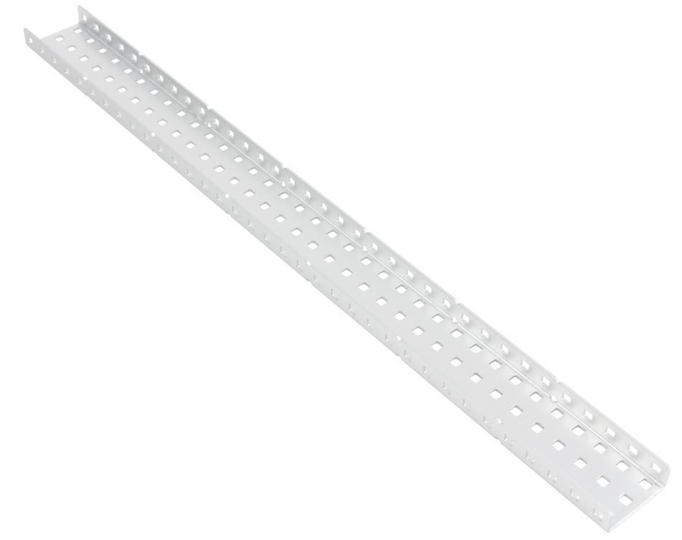

Plates | - Usually 5 (holes) wide  - Weak (bendy) so not usually used  - Used for mounting things such as a cortex | 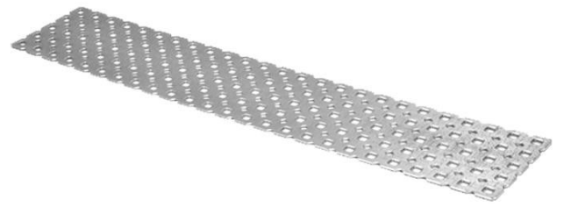
1-Bars | - 1 (holes) wide  - Long/thin and extremely lightweight  - Weak (bendy) so not usually used  - Used for slight support or small/unique gadgets | 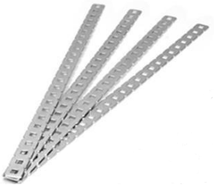
C-Channel | - 2, 3, 5 (holes) wides  - Very strong and sturdy  - Used primarily for structure  - Most common  - There are 1 wide c-channels, but they are usually hand made and are not supported by vex | 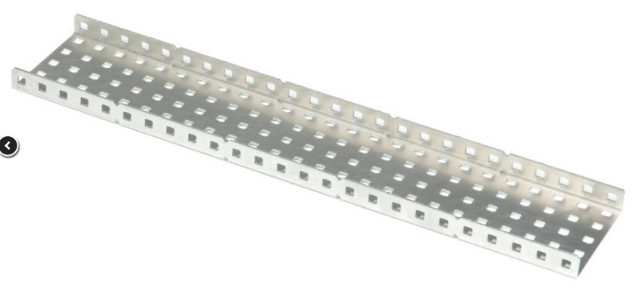  5 wide  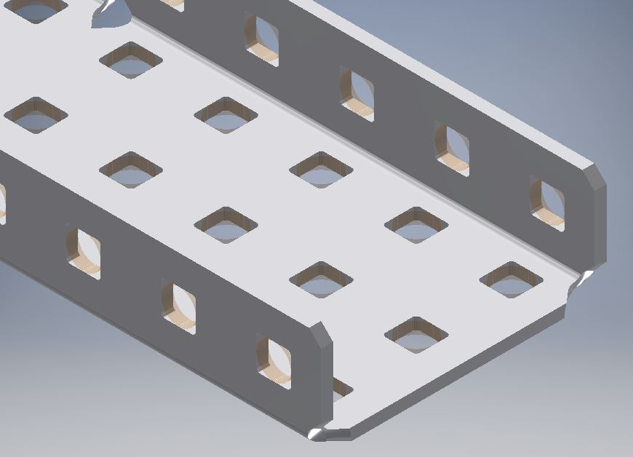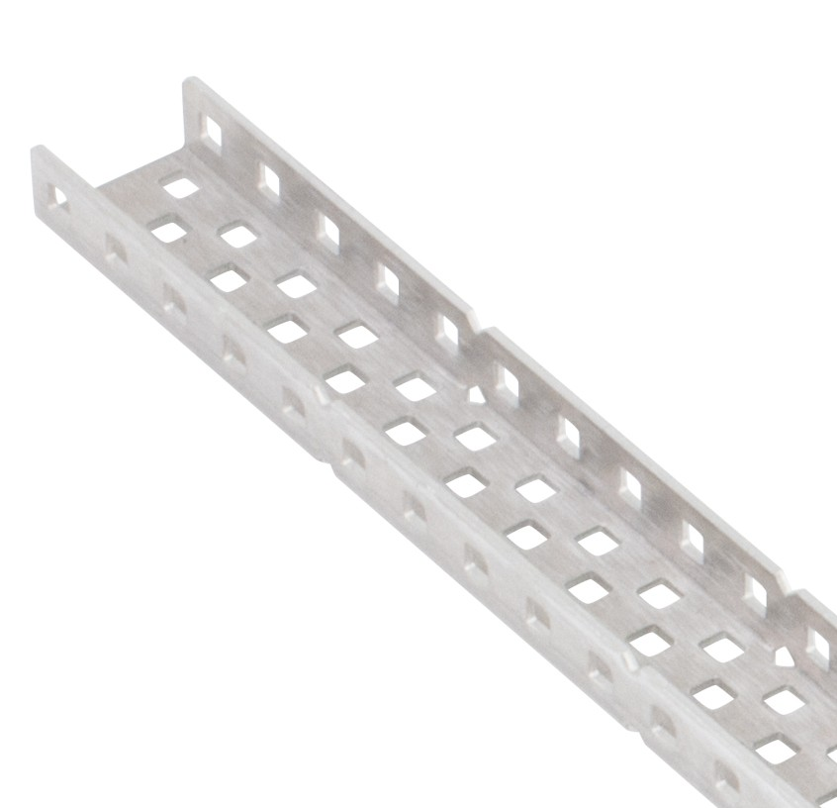  3 wide 2 wide
Angle | - 2 or 1 (holes) wide  - strong and sturdy (less so than a c-channel)  - Used primarily for structure  - C-channels can be cut in half to make 2 angled pieces for a smaller and lighter piece | 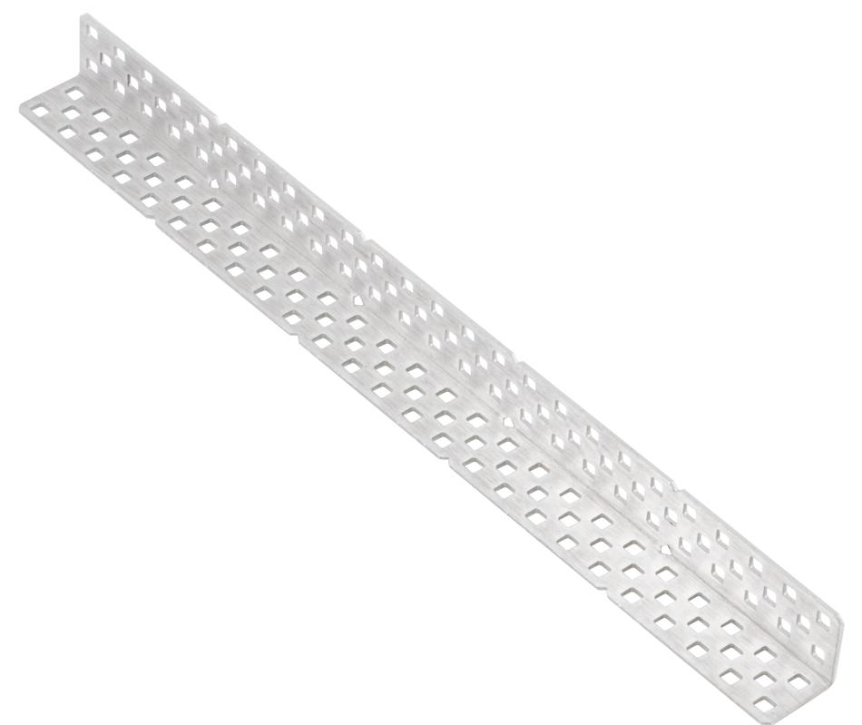
Rails | - 2 wide  - strong and sturdy (less so than a c-channel)  - Used primarily for structure | 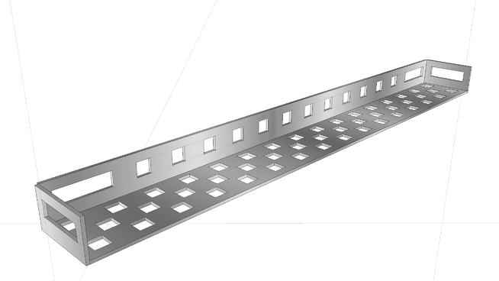
Linear slides | - Very strong and sturdy  - Used to translate rotary motion into perfectly linear motion  - 2 parts - Both parts are the same shape but one is smaller so it can go into the other  - Unstable at distances greater than 18 inches  - Generally have a lot of friction  - Lubricating decreases it (makes it run better) | 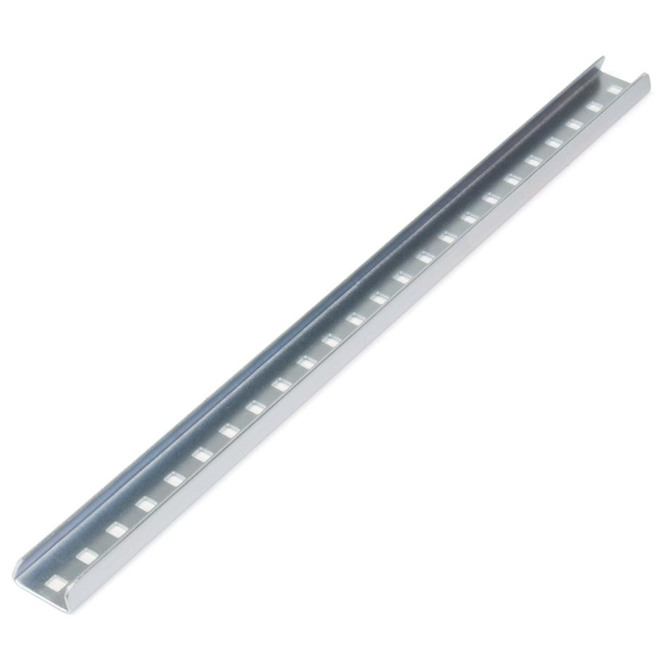

Motion Parts
- Shafts (Axles)
  - High strength (1/4" width) vs regular (0.125" width)
  - Used whenever there rotation is required, screws and sometimes used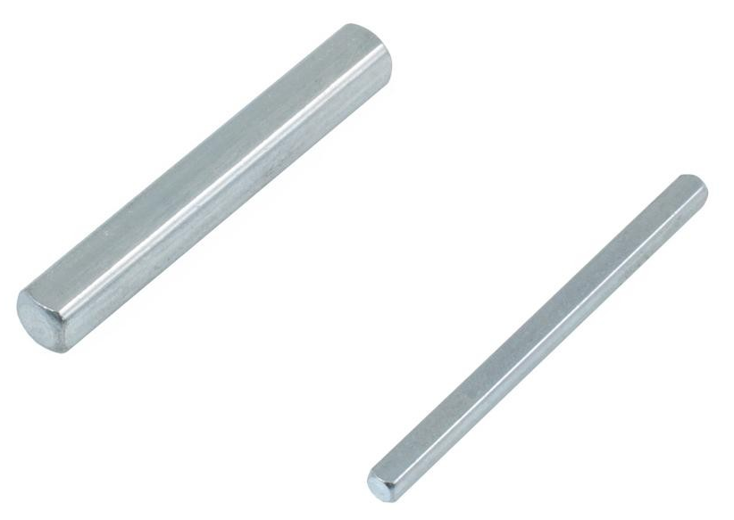
    - Generally low strength ones are used
- Shaft Hardware
Bearings (motor mounts) | - Attached to metal, 2 screws + 1 axle  - Reduces friction and allows for smooth rotation, prevents damage  - Used to connect motors  - Also called motor mounts  - Pillow boxes perform the above functions but the hole is 90॰ to the orientation  - Lock bars restrict an axle from moving relative to the connected metal
Spacers | - Used to fill empty space on an axle  - Prevents side to side motion  - White spacers, Nylon (⅛”,¼”,⅜”,½”)  - Black spacers, Plastic (4.6mm, 8mm)  - Shaft Collar- act as mechanical stops for axles  - Washers - used for precision spacing  - White (Teflon), Gray (Streaks eel) | 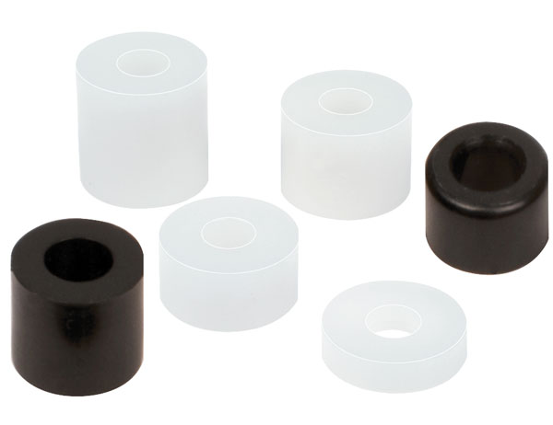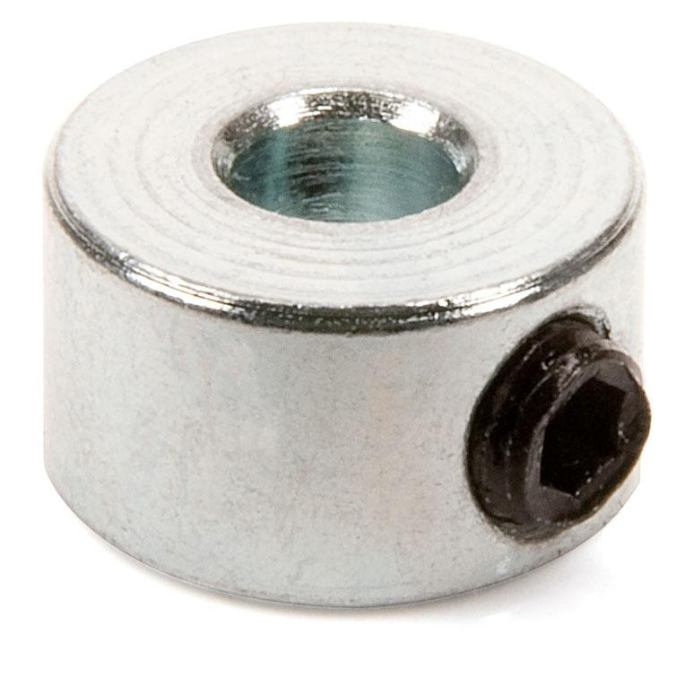  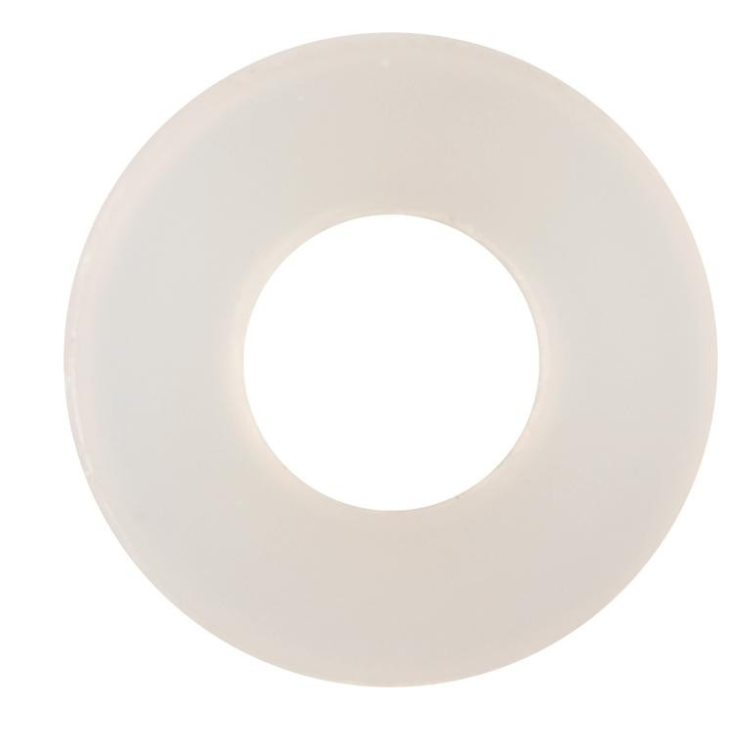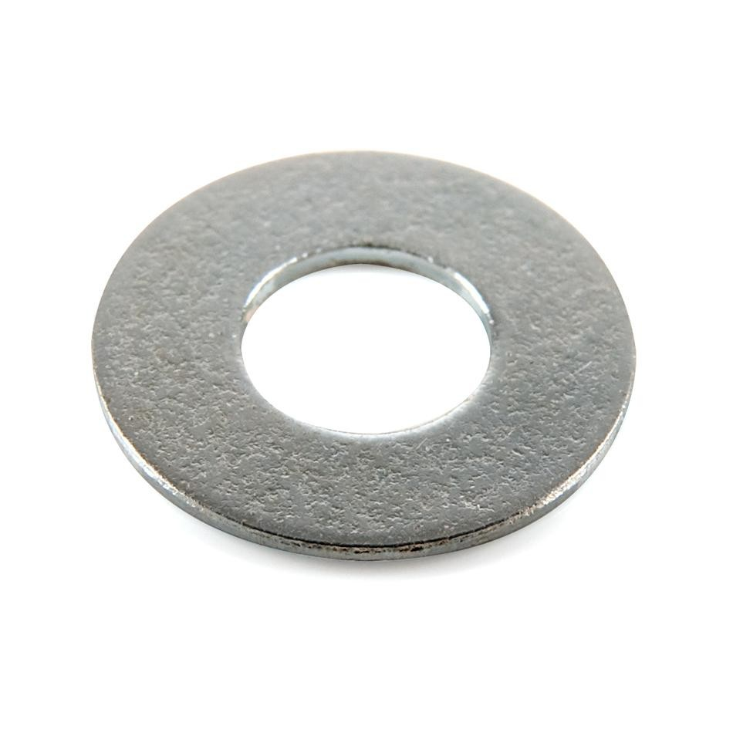

- High Strength vs Low Strength (gears and sprockets)
  - Usually use high strength because low strength is too weak for most situations
  - Use low strength for small things requiring weight reduction
- Gears (4 different sizes)
  - Used to transfer rotation throughout a robot
    - Change the speed/torque of a moving part, or the direction of rotation
  - 4 different sizes: 12 tooth (metal), 36, 60, 84 tooth (plastic)
- Sprockets & Chain
  - The teeth of the sprocket connect indirectly with each other by chain
    - Can change speed/torque but everything spin in the same direction
  - 5 different sizes: 6, 12, 18, 24, 30 tooth (High); 10, 15, 24, 40, 48 tooth (Low)
  - Used to connect different parts of motion over long distances
  - Should not be used to link 2 gears that are powered separately
  - Chain can also have tank treads or other accessories attached if needed
- Special gears
  - Consult your mentors for more information

Low Stren. | High Stren. | Special | Low sprock. | High sprock.
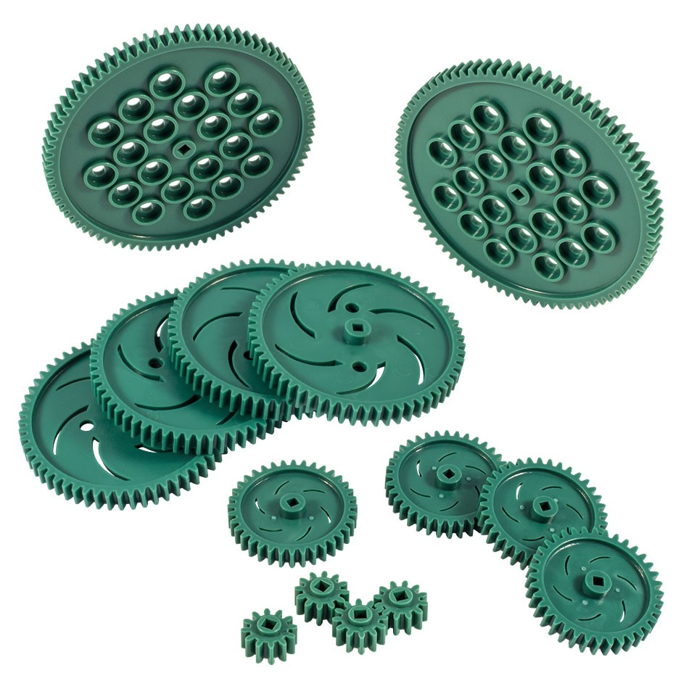 | 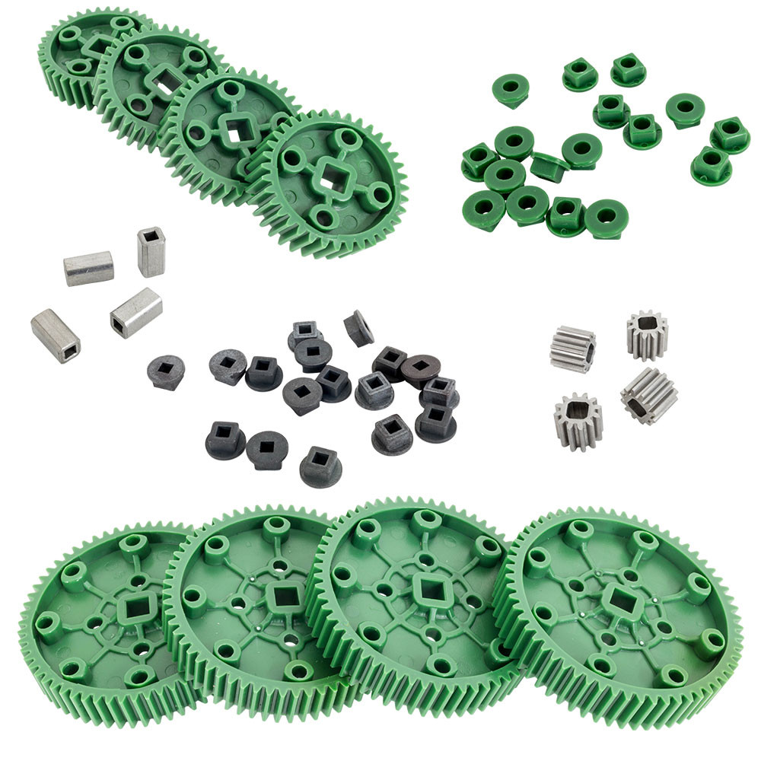 | 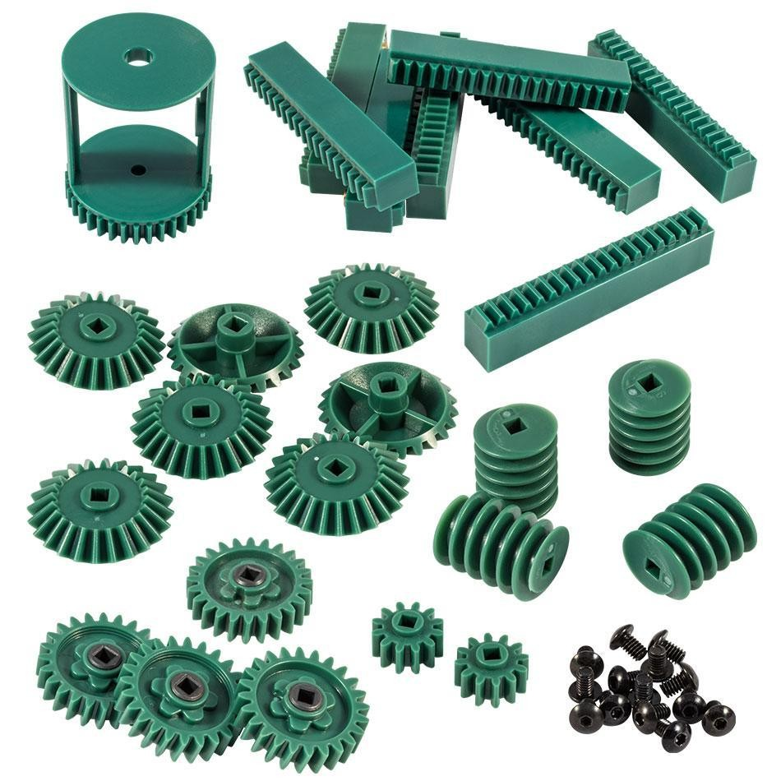 | 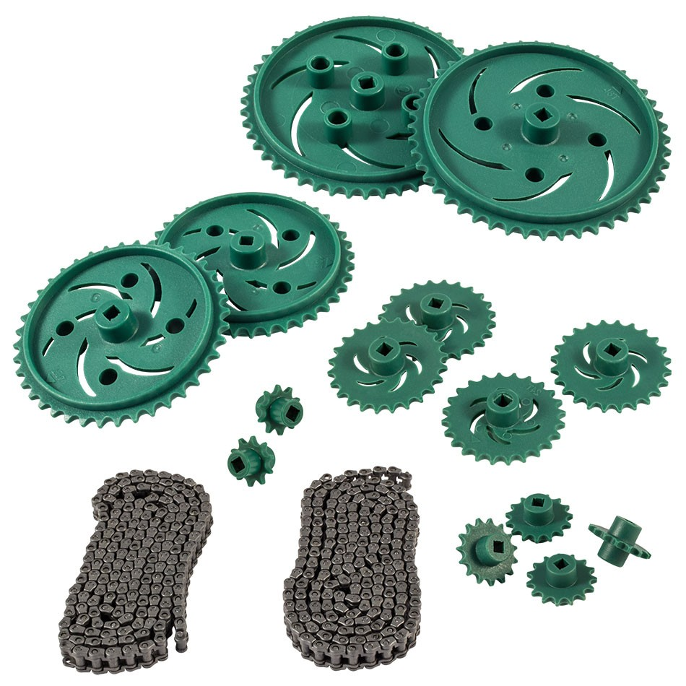 | 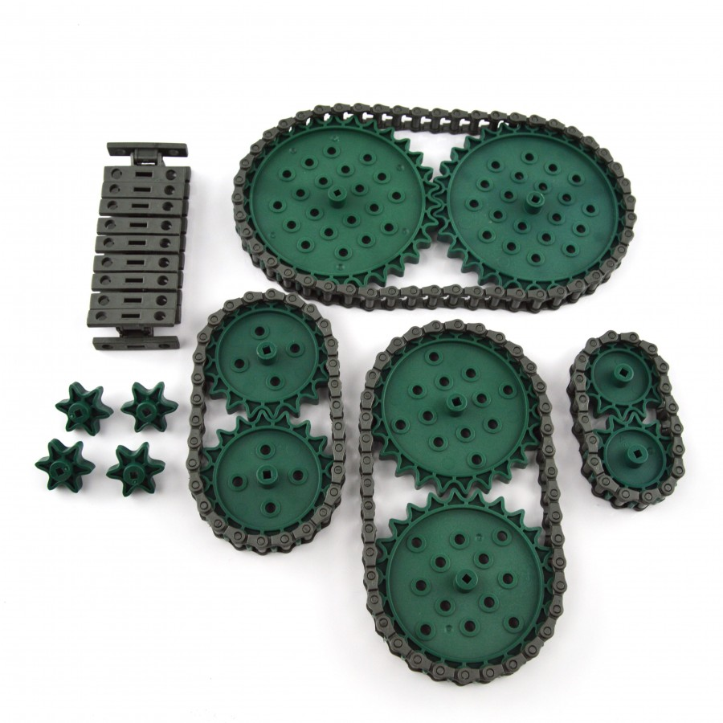

- Gear Ratios
  - The Mechanical Advantage (MA) of a gear system
    - How much it amplifies the force
  - Gear Ratios (# of times a 2nd gear spins in relation to the 1st gear)
    - Driving:Driven or Driven/Driving, most often used, ex. 1:1, 1:5, 1:7
  - Can be geared for more speed or Torque
    - Torque - More rotational force, less speed (rpm), higher MA
    - Speed - More speed (rpm) , less rotational force, lower MA
  - Idle gear - all the gears between the driving and driven gear.
    - Only affect direction unless they are in a compound gear system
      - (different sized gears on the same axle, more complicated)
  - Most gearing in robotics is to torque
- Wheels
Omni-Directional Wheel | - Most commonly used wheel type  - It is a large wheel with smaller wheels going along the outside which allows it to have sideways motion  - Allows for good turning | 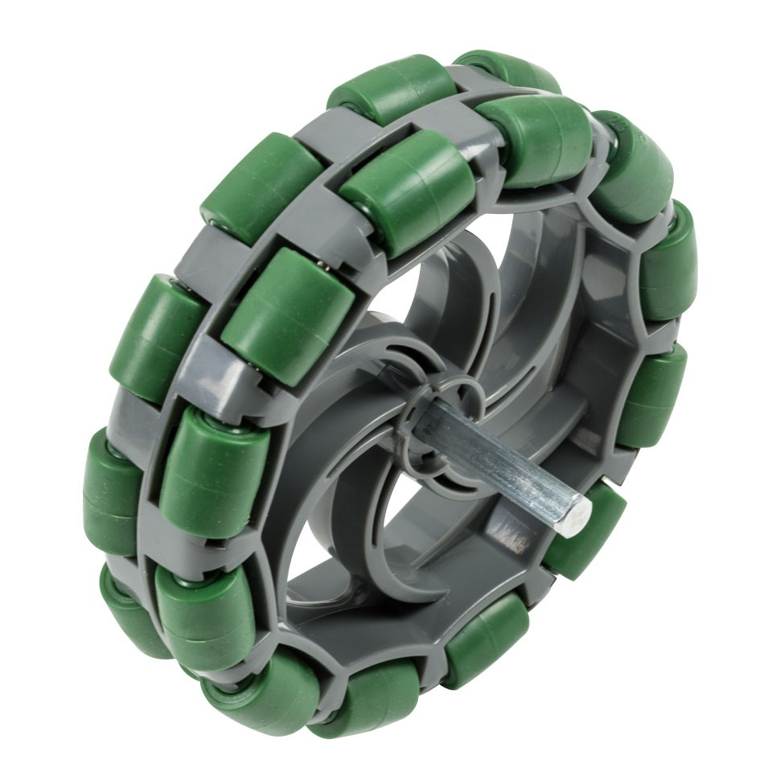
Mecanum Wheels | - Allows for an x-drive to be built with a regular chassis  - X-drive - special kind of drive, more maneuverability, less speed  - Not generally used | 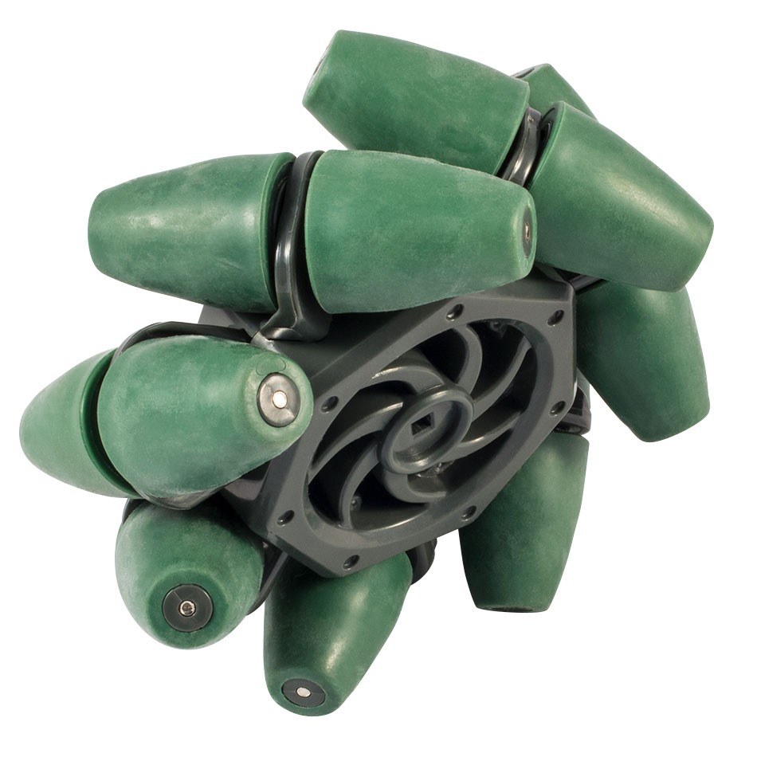
Random Wheels | - Quite a few types of wheels  - Could be used if the situation arises, but generally not used | 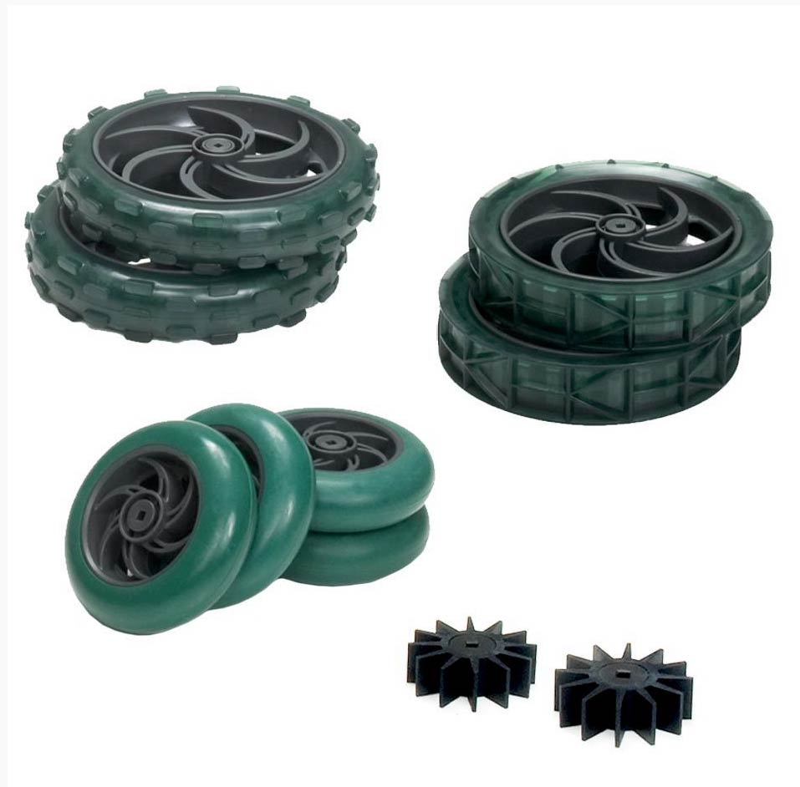
- Pneumatics
  - Probably won't use
    - Can be single acting or double acting pistons
    - Consult your mentors for more information

Hardware
8-32 (dia) Screw | - For nuts, standoffs, shaft collars  - 0.25, 0.375, 0.5, 0.625, 0.75, 0.875, 1.0, 1.25, 1.5, 1.75, 2.0 inches | 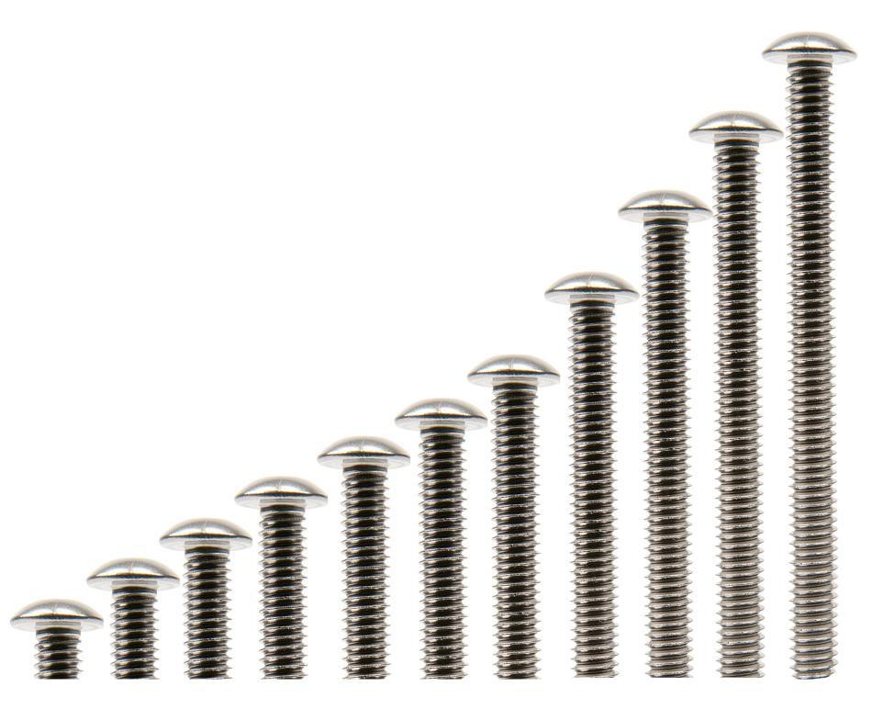
6-32 (dia) Screw | - For motors, rack gear attachments  - 0.25, 0.5 inches | 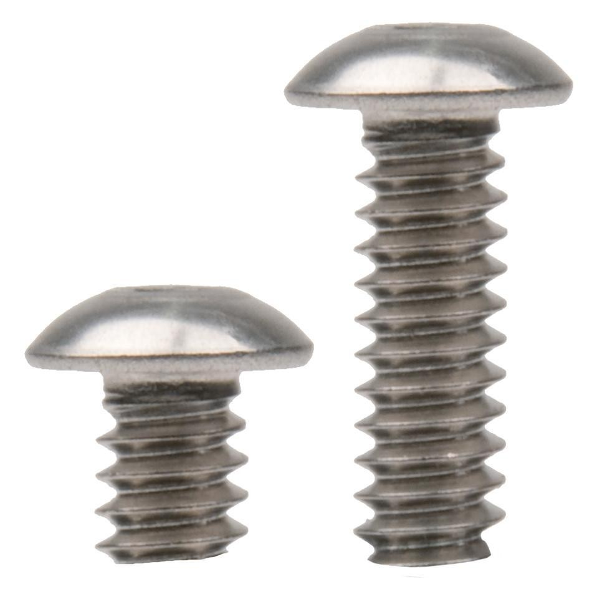
Hex Nut | - Standard nut, not generally used, may be used for prototyping
Kep Nut | - Most often used, prototyping or final build  - Easy to put on, when tightened it grips into the metal with its “teeth” on its bottom  - Can come loose if not tightened well
Nylock nut | - Used a lot as well but hard to put on  - Requires a wrench to tighten  - Strong and doesn’t come loose  - Can be used with a screw for a rotating joint
Standoffs | - Used to “stand”/attach metal off of each other  - Good for structure, lightweight  - Can be combined by couplers  - (screws with no round top)  - 8-32 screws | 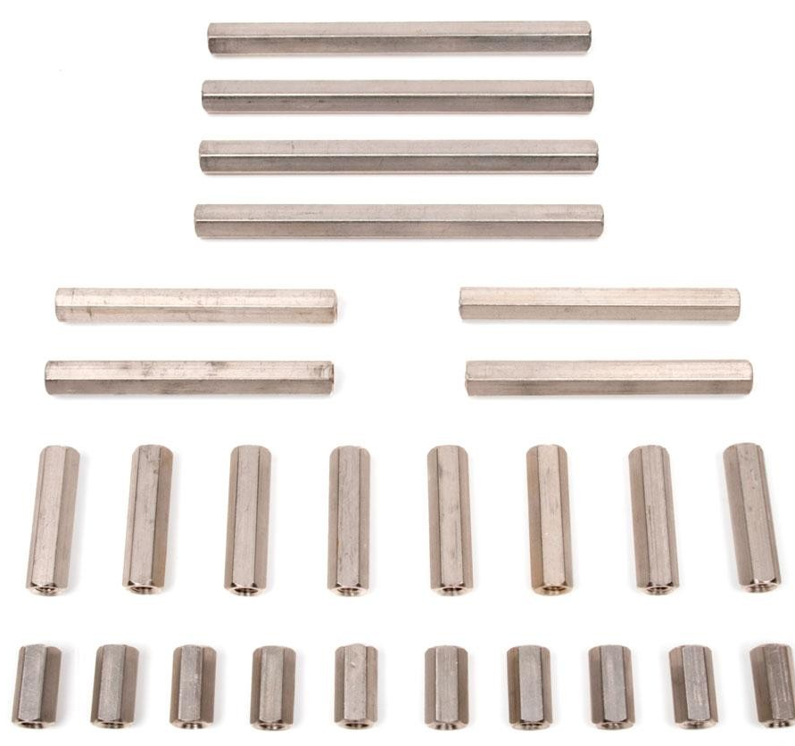
Rubber Link | - Can be used to attach standoffs at special angles  - Not generally used | 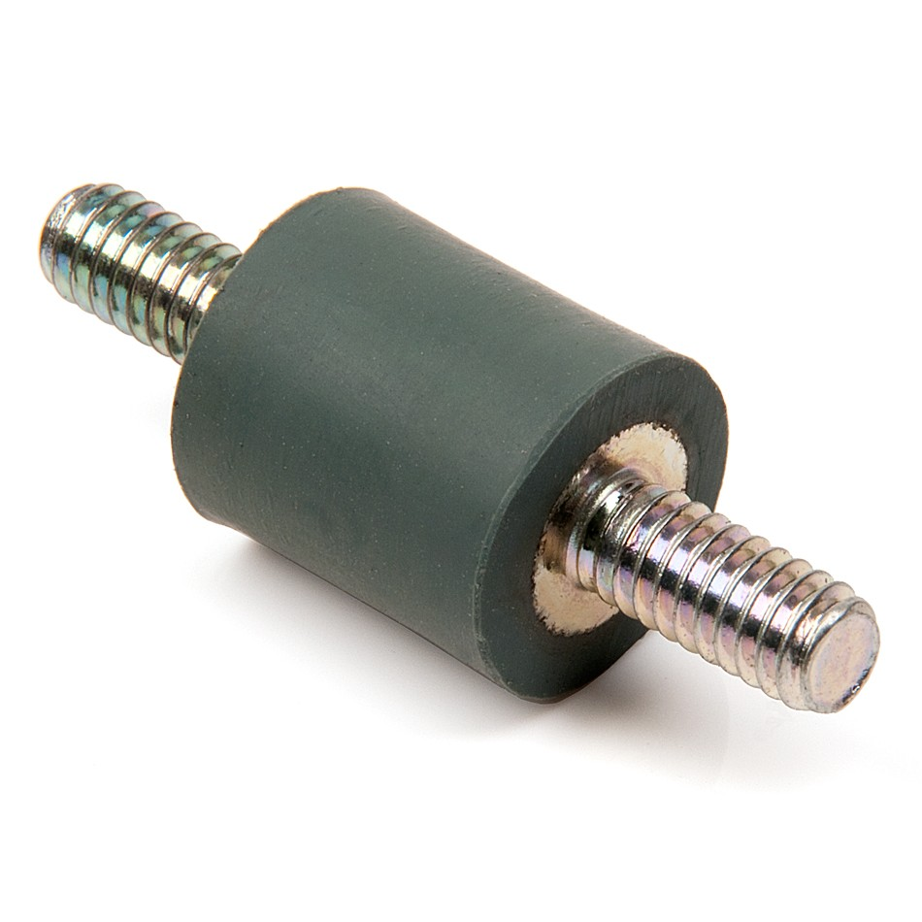
Hinges | - Used to make a joint  - Usually for things that need to be deployed outside the 18” | 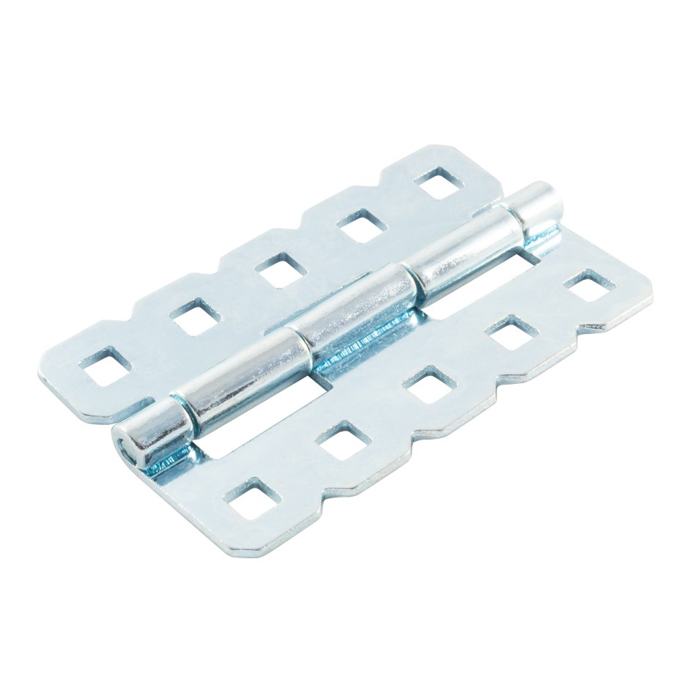
Gussets | - Various items that help improve structure  - May not be used if it’s inconvenient and the robot is sturdy enough | 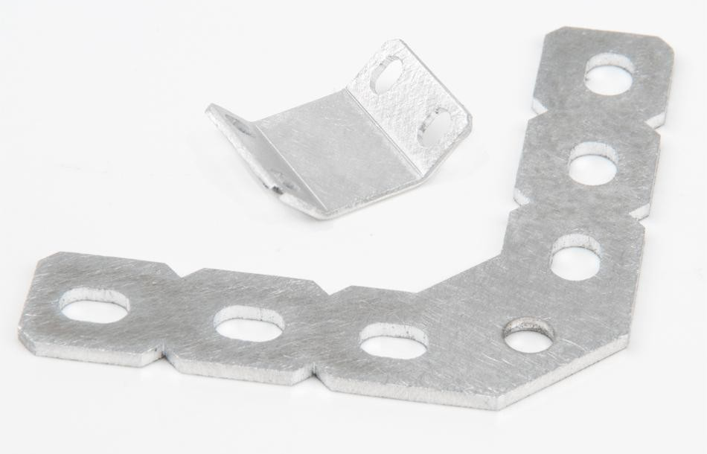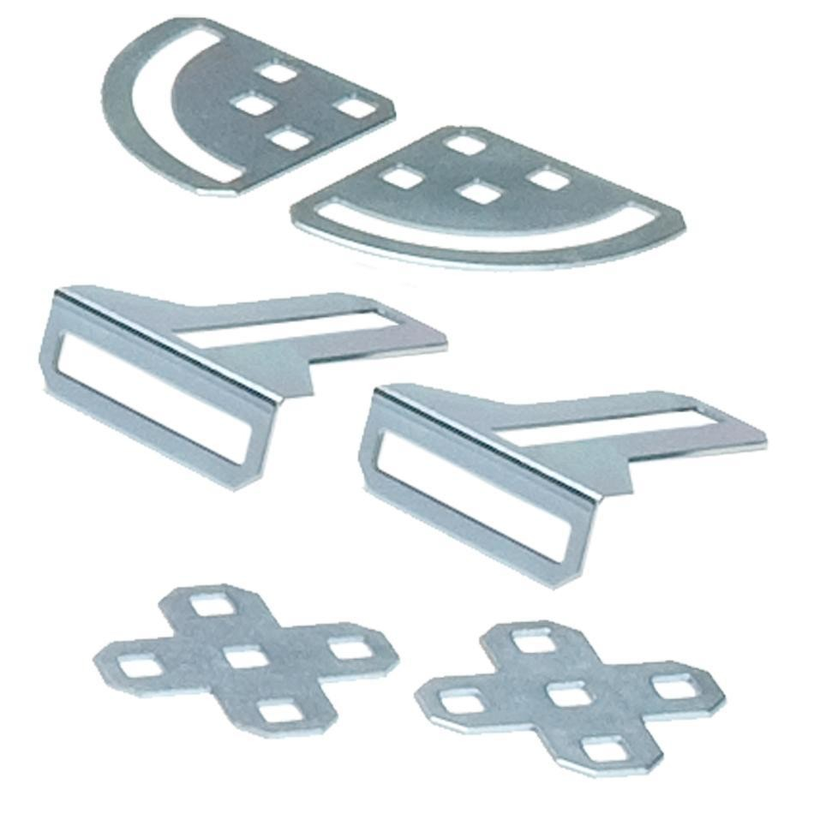

Tools
- Allen Keys/Drivers
  - Used to loosen or tighten screws, most Common Screw Head in Vex is Hex
  - 3/32” Keys used for 8-32 screws (larger),
  - 5/64” Keys used for 6-32 screws (smaller), set screws for shaft collars
  - or 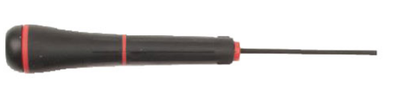or 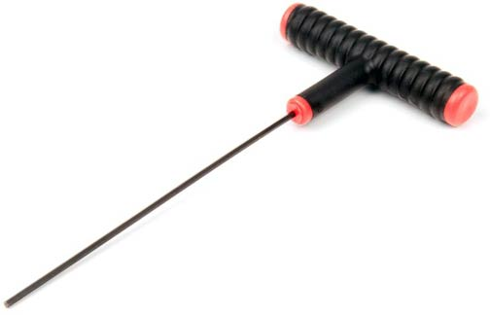
  - Ball point Hex keys allows for angled used; good for hard to reach areas/angles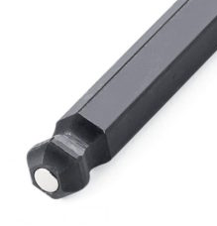
- Torx Star Keys
  - New and may or may not be used
  - Screws are the exact same except for the head
  - 8-32 screws with T15 sized keys
  - 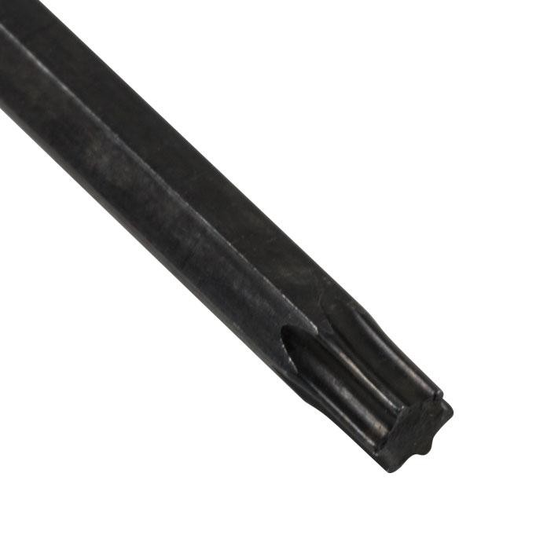← Screwdriver bit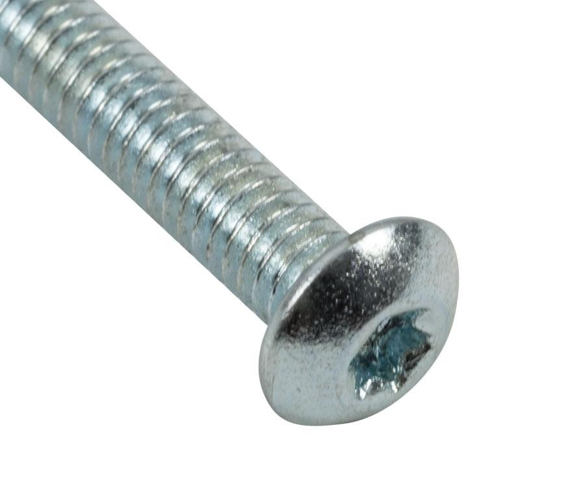← Screw Head
  - 6-32 screws with T8 sized keys
- Wrench
  - Used to rotate nuts and standoffs
  - Larger side for nuts →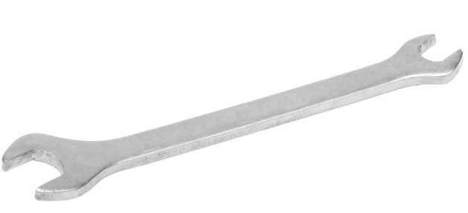← smaller side for standoffs
  - Used to rotate nuts or keep them still; the long length allows for high torque making it perfect for tightening it really well
- Safety Glasses - Wear These when using power tools or a hacksaw, don’t be dumb
- Power Tools
  - Not for use by new and untrained members (get PERMISSION before use)
  - Rotary tool/portable drill/dremel - Used to cut or sand things in particular metal
  - Angle Grinder- it’s like a dremel, but bigger, shaped different.
  - Drill press- Used for drilling
  - Grinder- Used for grinding
  - Sander- Used for sanding
- Other Common Tools
  - Pliers - used to grab and hold onto things, pull things apart
  - Scissors/Zip-Tie cutters - cuts string, zip times, wires if need be, and other things
  - File/Sandpaper - used to smooth items out or decrease length by a tiny amount
  - Hacksaw - Don't use without permission. Use for cutting metal precisely

Electronics
- The parts that tell the robot to run
- There parts with are before the v5, some may still be usable with “legacy” ports
Cortex | - The brain of the robot  - 10 motor ports  - 8 analog and 12 digital sensor ports  - 3 I2C ports  - Code is downloaded and stored on this | 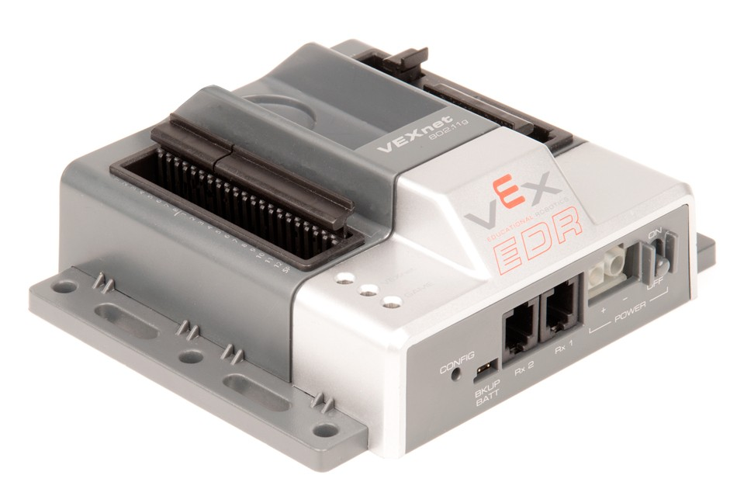
Joystick & VexNets | - Used to control the robot manually  - Requires 6 AAA batteries  - 2 joysticks, 8 top buttons, 4 back buttons  - Can be connected to the robot with a usb-usb cable or wirelessly via vexNets  - Need two vexNets  - Can be connected to another special joystick for dual control with a cable | 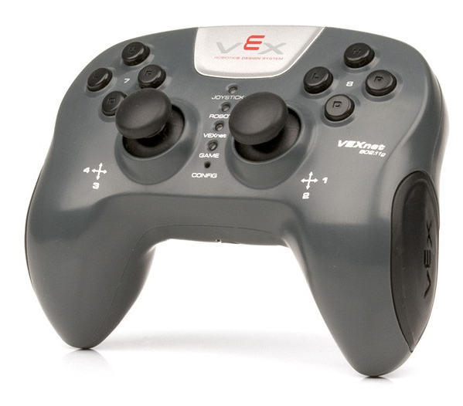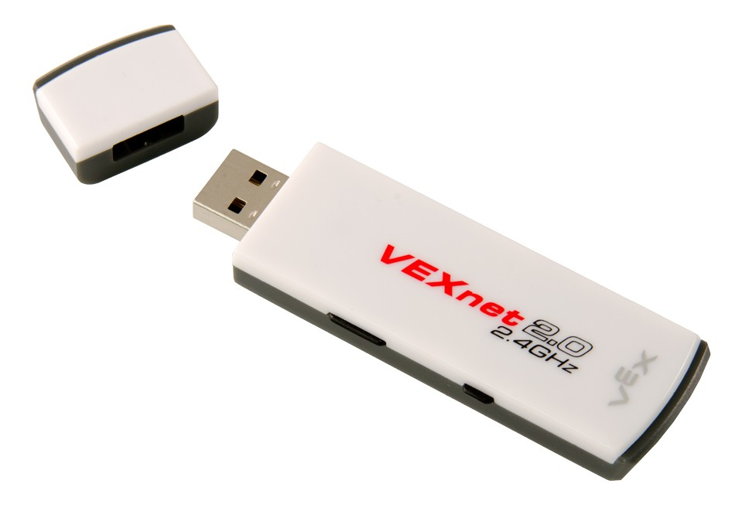
Motor Controller | - Used to connect motors it ports 2-9  - Convert the motor wire from 2 to 3 pins  - Helps control the motor  - Ports 1 and 10 don’t require one | 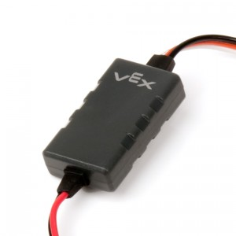
Wires / Y-Splits | - Act as an extension of the wire  - 2 pin extenders connect before the motor controller (very rare)  - 3 pin extenders connect to sensors and after a motor controller  - Y-Cables allow for 2 motors to be connected into one motor (3 pins) | 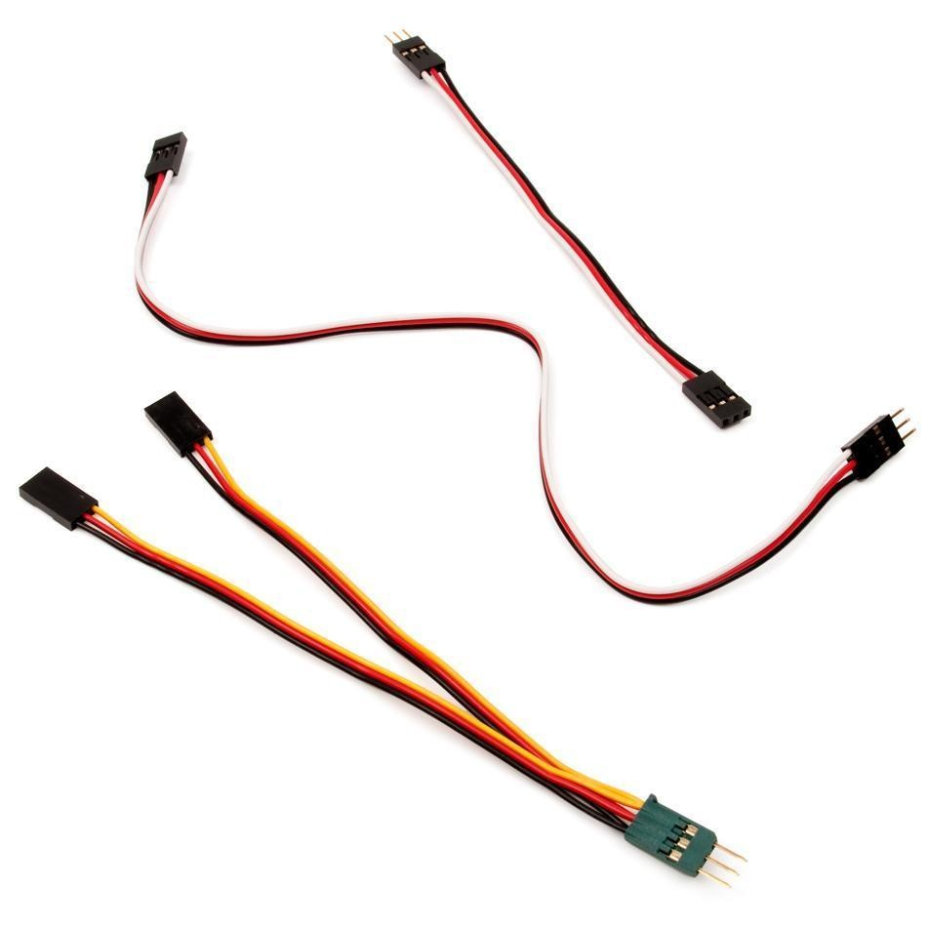
Motors (393) /Servos | - The primary source of motion on your robot.  - You can either use 12 motors OR 10 motors and pneumatics  - Servos are mini motors with a limited range of rotation, not generally used  - Can be geared most Torque, speed, and turbo  - Torque - most force, slowest  - Speed - medium  - Turbo - fastests but less force | 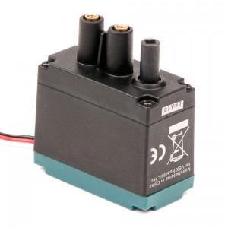
LCD Display | - Has an interactive display that can be programmed (3 buttons)  - Used to display information or select auton  - Uses a 4 pin Y-cable  - Plugs into the I2C ports | 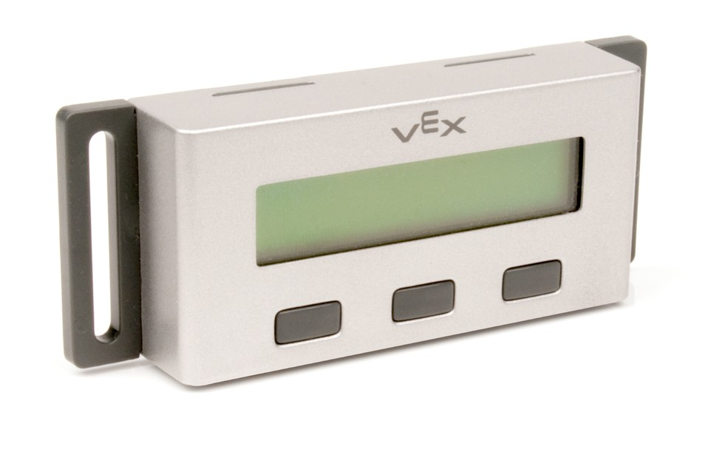
Batteries | - Main (blue) batteries charge everything  - 2000 mAh (bottom) almost never used  - 3000 mAh (top) most used  - Can run on safe and fast charge  - Never charge on fast for long periods of time  - Should be charged upt to 8.5Vs  - Power expander can be added to spread out the load of motors onto two batteries  - Expander contains 4 motor ports  - Backup Battery - required at competitions  - Keeps the cortex/VexNets alive if the main battery dies | 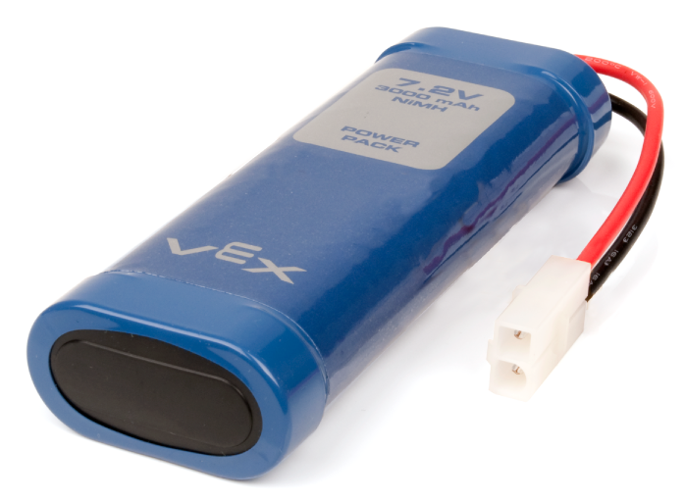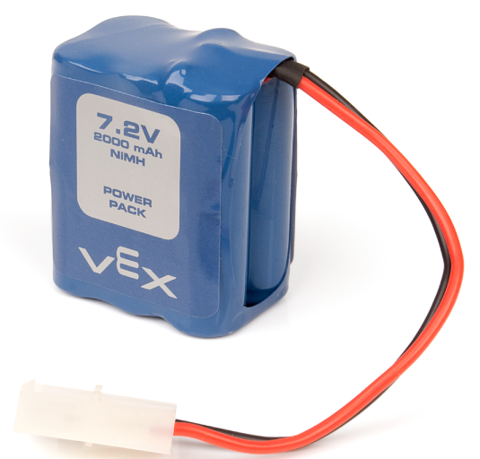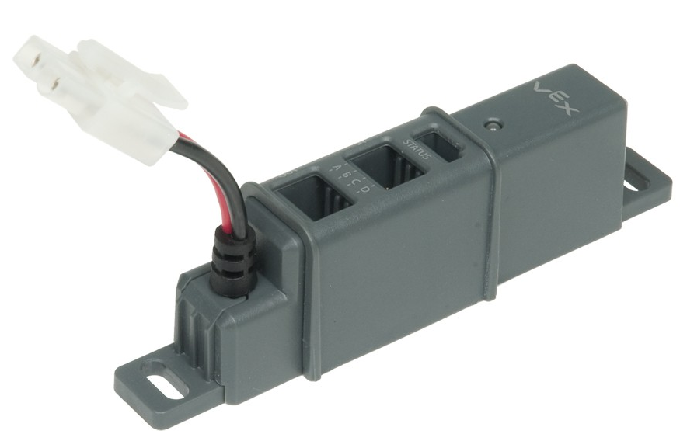  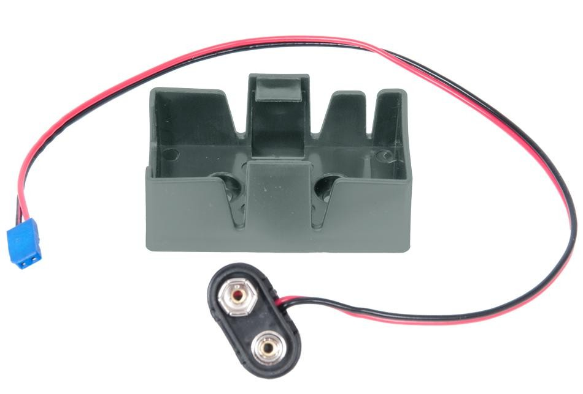

- Sensors
Limit Switches and Bumper Switch | - Act as buttons, both digital sensors  - Give a value of 1 (pressed) and 0 (released)  - The limit switch (right) is more fragile and sensitive | 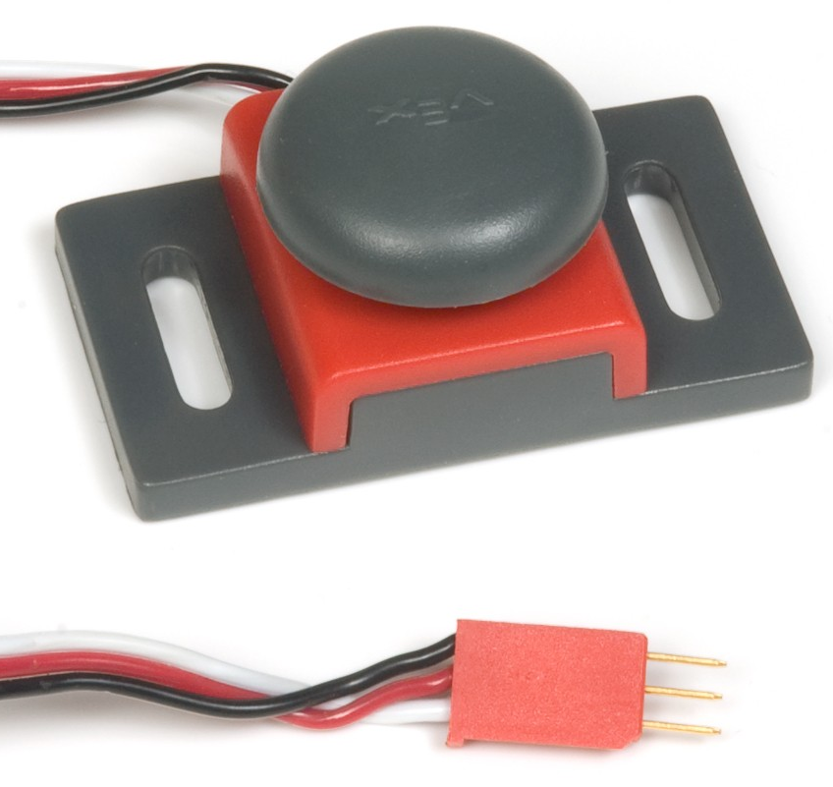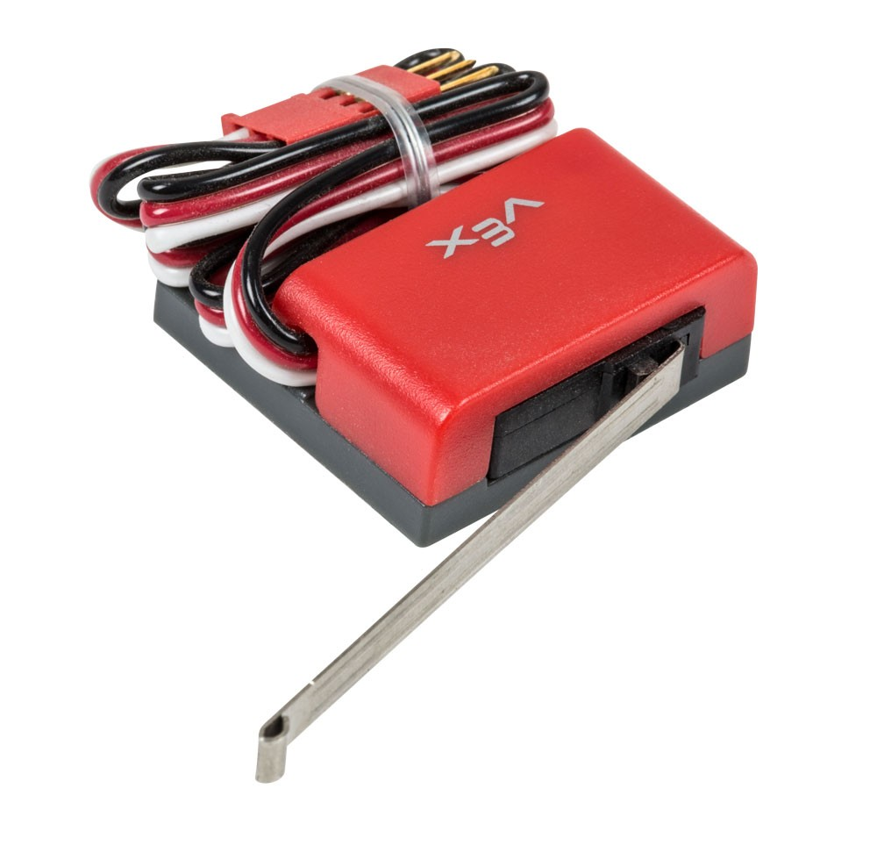
Ultrasonic | - Uses echolocation to determine a distance  - From 1.5” to 115”, analog sensor | 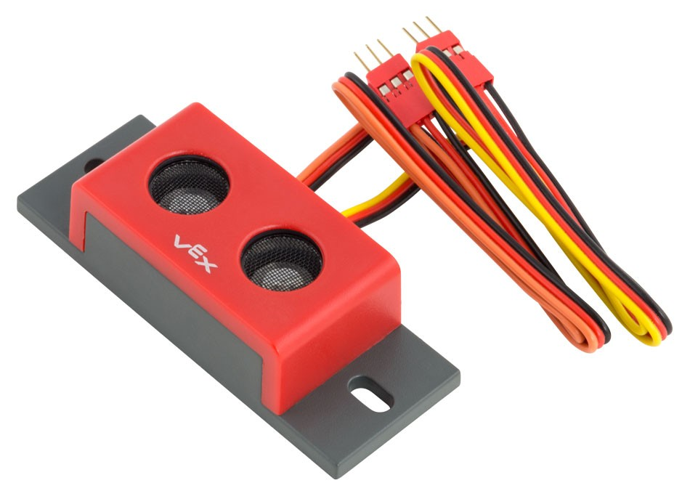
Quaniture encoders | - Detects the amount of rotation  - unlimited range, digital sensor  - 90 “ticks” for one revolution (360°)
Potentiometers | - Detects the amount of rotation, analog  - Only 250 degrees of range  - 4095 “points” that the sensor can read  - Common among lifts | 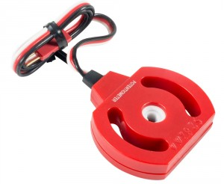

Programming
- Vex Robotics Beginner Guide Programming

Lifts/Devices
- Arm
  - Most Basic Lift
  - 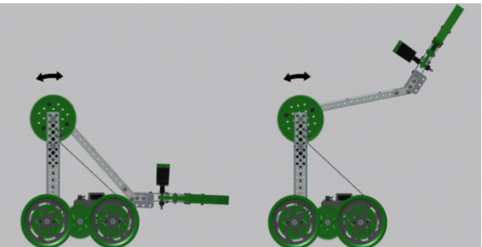
- Four bar lift
  - Similar to the arm lift except it contains more arms/bars
    - The configuration of the joints allow the gadget at the end to keep its original angle instead of changing with the arm
  - 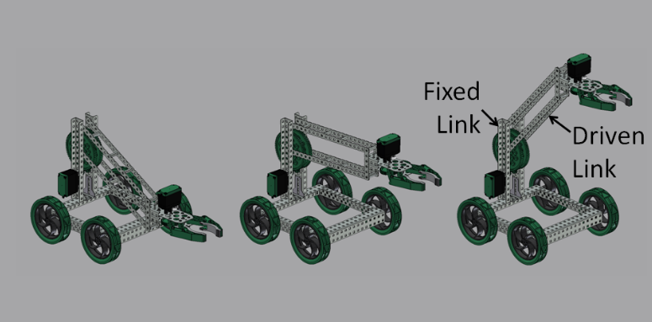
- Six bar lift
  - Similar to the 4 bar except it has 6 bars in this configuration
  - It goes higher than a 4 bar
  - Theoretically it can go to infinity with even numbers (ex. 8 bar), but people usually stop at 6 because of materials and the number of joints
  - 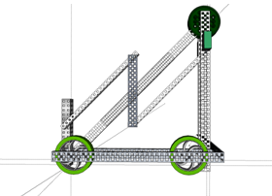
- Double reverse four bar (dr4b)
  - Two 4 bars that are connected with a large gear
  - Tall but may be unstable, require a lot of materials to build
  - Theoretically can use an number bar (ex. Double reverse 6 bar) or have infinity bars (triple, quadruple, etc.)
  - 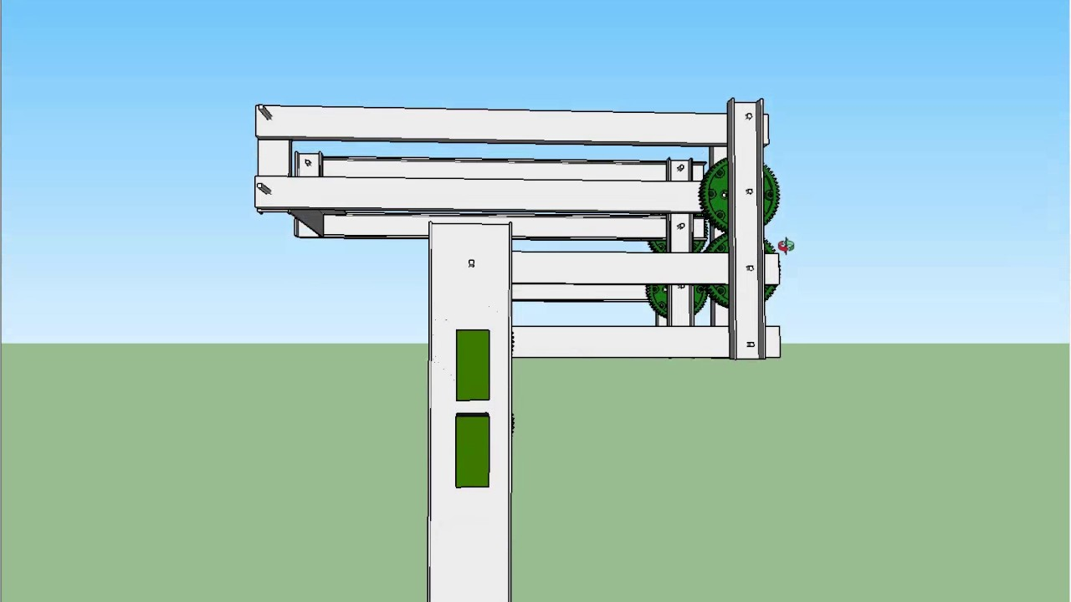
- Scissor lift
  - Really tall and hard to build
  - Slow and unstable, can easily bend the metal structure
    - Not usually used
  - 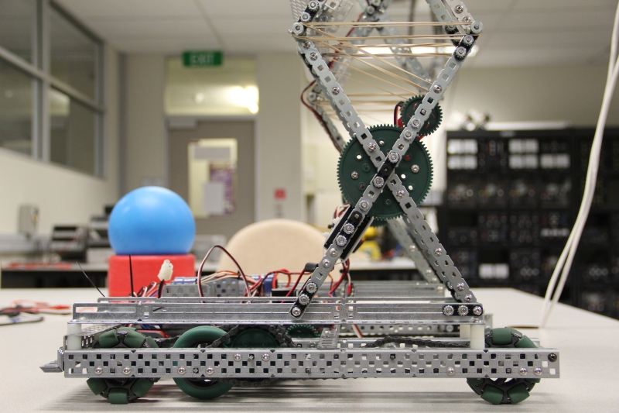
- Flywheel
  - Used to shoot objects
  - Require high gear ratios
  - 