Notes:
- This is technically not a bulleted list.
- Be sure to go into Design Mode to edit the ‘template’ and understand better how the Repeating Section Content Control works
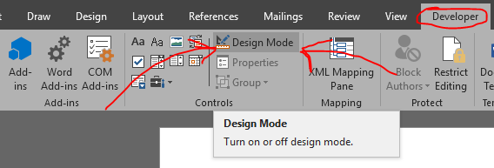
- Right-click on ‘list items’ for more options:
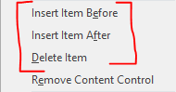
☒ This
☐ is
☒ a
☐ Repeating
☒ Section
☐ Content
☒ Control
☐ with
☒ a
☐ nested
☒ checkbox,
☐ tab
☒ indent,
☐ and
☒ Rich
☐ Text
☒ Content
☐ Control.

